Final Exam CS-GY 6003 INET Spring 2021

May 18, 2021

**Instructions:**

**Scheduling:** • The exam runs from 6:00pm to 9:30pm EDT on May 18th 2021. The exam is run through Gradescope. Your exam must be resubmitted electronically before Gradescope closes at 9:45pm. Ensure that you know how to digitally scan any handwritten material. This is entirely the student’s responsibility.

**Format:**

* The exam consists of 4 questions, for a total of 100 points. You should plan for 45 minutes per question.
* You may write your solutions directly on the downloaded exam paper, *or* in your own format. You are responsible for providing clear and legible solutions to the problems.

**Questions during the exam:**

* There is a ZOOM session for questions that will be open during the entire course of the exam, MICROPHONES OFF. You may ask questions via private chat to the instructor during the exam. Any announcements made by the instructor during the exam will be made over ZOOM and also be email. **It is the student’s responsibility to stay connected (either by ZOOM or email) during the exam.**

**Rules:**

* This exam is a **take-home exam**. You may use **only** the resources from the online class (any material on NYU classes for this course) and any type of calculator (although it is not needed).
* Your work must be entirely your own. It is **forbidden to discuss any work with** *any* **other person**. Furthermore, your work must be done without using internet searches (although this is completely unhelpful for this exam). Any breach of academic honesty will be handled in accordance with the *Student Code of Conduct*, (a copy of which is provided), and in this particular case, taken very seriously.
* You are asked to **read** the attached Student Code of Conduct Section III subsections A,B,C,D,E and **sign** below to acknowledge that you aware of the policy. Once signed, a copy of this page must be uploaded with your exam.

**I acknowledge that my submitted Exam work is entirely my own. I have read and am in accordance with the Student Code of Conduct policy of NYU Tandon and fully accept the consequences of breaching the above instructions.**

Name:

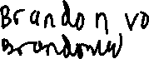

Signature:

**ZOOM LINK:** <https://nyu.zoom.us/j/97755000552>

# Question 1: Recurrences

**Show your work**

1. **5 points** A set of *n* children would like to divide up into teams, where each team is either size 2 or size 3. Let *T*(*n*) be the number of ways of dividing the children into such teams. Give a well-defined recursive definition for *T*(*n*), including any necessary base cases. You do not need to solve the recurrence.
$$Team of size 2 or 3 required, meaning atleast 4 children$$

$$For teams of 2, there are 2*2 ways to set up a team$$

$$For teams of size 3, there are 3*3 ways to arrange two teams of size 3$$

$$T_{n-2}=Two children are used to make a team. n-2 children left$$

$$T_{n-3}=3 children used to make a team. n-3 children left.$$

$$T\left(0\right)=1$$

$$T\left(1\right)=0$$

$$T\left(2\right)=4$$

$$T\left(3\right)=9$$

$T_{n}=T_{n-2}+T_{n-3}$

2. **7 points** Suppose you have *m* identical blue books and *n* identical yellow books. Let *B*(*m,n*) be the number of ways to arrange the books on the shelf. Write a recurrence relation for *B*(*m,n*), including necessary base cases. Next, suppose you can’t put two yellow books in a row. Rewrite a new recursive definition for *Y* (*m,n*), which is the number of ways of arranging the books under this condition. You must justify both of your expressions. You do not need to solve the recurrences.

Assuming all books are of size 1, meaning each book fills up one slot on a shelf

$$B\left(0, 1\right)=1 yellow book$$

$$B\left(1, 0\right)=1 blue book$$

$$B\left(m-1, n\right): Add one blue book, meaning m-1 book slots left$$

$$B\left(m, n-1\right): Add one yellow book, meaning n-1 book slots left$$

$$B\left(m, n\right)=B\left(m-1, n\right)+B(m, n-1)$$

If no two yellow books can be put next to each other

$$Y\left(0, 1\right)=1 yellow book$$

$$Y\left(1, 0\right)=1 blue book$$

Needs an additional two base cases to account for the lack of Yellow, Yellow

$$Y\left(m-1,n\right): 1 Blue no change needed$$

$$Y\left(m, n-1\right): 1 Yellow, no change needed$$

$$Y\left(0,1\right): 1 Yellow, no change needed$$

$$Y\left(1, 0\right): 1 Blue, no change needed$$

$$Y\left(1,1\right): 1 blue, 1 yellow, no change needed$$

$$Y\left(2, 0\right): 2 blue, no change needed$$

$$Y\left(0, 2\right): 2 Yellow, not permitted$$

$$Y\left(m-2, n\right): 2 Blue books, no change$$

$$Y\left(m-1, n-1\right): 1 Blue, 1 Yellow, no change needed$$

$$Y\left(m, n\right)=Y\left(m-1, n\right)+Y\left(m, n-1\right)$$

1. **8 points** In year one, an investor deposits 3 dollars in her bank account. Each year after that, the balance in the account triples, **but** a bank fee is paid at the end of the year. The bank fee is 2 dollars at the end of year two, and the bank fee doubles every year after that. Let *A*(*n*) be the account balance at the end of year *n* ≥ 1. Give a recursive definition for *A*(*n*), including any necessary base cases. Solve the recurrence and prove your result using induction.

$$Investor deposits 3 dollars: a_{1}=3 dollars$$

$$a_{2}=6 dollars$$

Because the bank fee is at the end of year 2, the first and second year must be a base case

$$Balance triples each year: a_{n}={3a}_{n-1}$$

$$Bank fee paid at the end of the year: a_{n}=3a_{n-1}-2$$

$$Bank fee doubles every year after that: a_{n}=3a_{n-1}-2^{n-1}$$

$$a_{n}=3a_{n-1}-2^{n-1}$$

$$a_{3}=3*7-2^{2}=17$$

$$a_{4}=3*17-2^{3}=43$$

$$a_{5}=3*43-2^{4}=113$$

$$a_{n}=3^{n}-2^{n+1}+2$$

|  |  |
| --- | --- |
| Week | Balance |
| 1 | 3 |
| 2 | 7 |
| 3 | 17 |
| 4 | 43 |

Proof by Induction

# Question 2: Number Theory

**Show your work!**

**(a) 6 points** Evaluate the following. You must justify the steps that you use to arrive at the answer, without using a calculator.

* 9283 mod 6
* 7161 mod 17
* 7161 mod 5
* 7161 mod 85

1. **6 points** Solve the following for *x* in mod 66. There are exactly two solutions:

2*x* = 4 mod 6

2*x* = 9 mod 11

$$Chinese Remainder Theorem:$$

$$Inverse of mod 6 with 11: 5$$

$$Inverse of mod 11 with 6: 2$$

$$4*11*5+9*6*2=328 mod 66$$

$$2x=64 mod 66$$

$$2x-64=0 mod 66$$

$$x=32 mod 66$$

$$x=32$$

$$2x-64=0 mod 66$$

$$2x+2=0 mod 66$$

$$2\left(x+1\right)=0 mod 66$$

$$x=-1 mod 66$$

$$x=65$$

1. **8 points** Given natural numbers *a,b,c >* 0. Suppose that gcd(a,c) = a and gcd(b,c) = b and that gcd(a,b) = 1. Prove that gcd(ab,c) = ab

$$GCD\left(a, c\right)=a$$

$$GCD\left(b, c\right)=b$$

$$GCD\left(a, b\right)=1$$

$$If\gcd\left(a, b\right)=1 and a|bc then a|c$$

This means that if a and b are relatively prime, then whatever value b is, it won’t affect a.

$$GCD\left(a, b\right)=a mod b=1$$

This means a and b are relatively prime and they don’t affect each other

$$For relatively prime numbers, multiplying them$$

$$Also for relatively prime,their GCD is taken from taking the smallest factors found in both A AND B$$

$$If A and B don^{'}t share any prime factors, there is no factorization that can be done on A and B$$

$$GCD\left(ab, c\right)=GCD\left(a, c\right)*GCD\left(b, c\right)$$

$$\gcd\left(a, c\right)=a,\gcd\left(b, c\right)=b$$

$GCD\left(a, c\right)*GCD\left(b, c\right)=ab$

# Question 3: Graph Theory

**Show your work**

1. **6 points** Suppose a connected graph *G* has degree sequence (3*,*3*,*2*,*2*,*1*,*1*,*1*,*1).

Does such a graph contain a cycle? Are all graphs with this degree sequence planar? Explain each of your answers.

$$Sum of all vertices: 3*2+2*2+1*4=14 vertices, even number$$

$$A connected graph must have n-1 edges, but there are 8 vertices$$

$$28 edges due to twice the number of vertices$$

$$Handshaking Lemma: 14*\frac{13}{2}>14$$

No, there is not a cycle in Graph G. This is a tree graph. There are not enough edges to form a cycle for the graph.

Planar:

$$Euclid^{'}s algorithm: v-e+f=2$$

$$e≤3v-6$$

$$e≤3\left(e-f+2\right)-6$$

$$e≤3e-3f+6-6$$

$$3f≤2e$$

It is not possible for this graph to be planar

Is it possible that two non-isomorphic graphs both have the same above degree sequence?

1. **8 points** You have exactly 16 balls. There are 4 red, 4 blue, 4 green, and 4 black. You are allowed to distribute the balls into 4 different buckets, in any way you want. Each bucket can hold a *maximum* of 5 balls. Show that no matter how you distribute the balls, it is always possible to select a different colored ball from each bucket.

$$P\left(Bucket\right)=\left({4 \atop n}\right)$$

Proof by contradiction: Attempt to disprove the question by showing that two buckets will have the same color of balls

The two buckets must have less than 4 balls. If one bucket has 4 balls, then it has all of one color. If it has 5 balls, then it must have two colors.

$$P\left(Bucket 1 has 1 color only\right): \left({4 \atop n}\right)$$

$$P\left(Bucket 2 has the same color as bucket 1 only\right)=\left({4 \atop 4-n}\right)$$

$$\left({12 \atop 8}\right): The rest of the balls go anywhere else$$

$$P\left(B_{1} and B_{2} | B_{1}\right)=\frac{\frac{\left({4 \atop n}\right)*\left({4 \atop 4-n}\right)*\left({12 \atop 8}\right)}{\left({12 \atop 5}\right)}}{\left({16 \atop 5}\right)}=0$$

The issue is that if those two buckets have only 1 color, then the maximum number of balls that one bucket must hold will be 4 balls. This can’t be done because 16 balls need to be distributed to all 4 buckets, and each bucket can hold up to only 5 balls. Two buckets cannot have 4 balls of one color only. This is also an issue due to Pigeonhole principle. By Pigeonhole principle, each bucket must have different colored balls.

1. **6 points** A vacation resort is made up of *n* islands, that are connected by bridges. Each island has either 1, 2 or 4 bridges connected to it. A vacationer goes for a stroll one day and determines that it is possible to start at his island, and visit every island exactly once. After his walk he is tired and takes a boat home. The next day, he leaves from his island and decides to walk over every bridge exactly once. Is this possible? Explain why or why not.

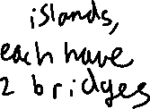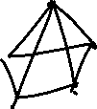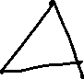

A K5 graph is sufficient enough to create a Hamilton Cycle. In a K5 graph, 5 islands have (n-1) or 4 edges, or 4 bridges connecting each other. There is a path formed where you can travel from any island to another and reach the starting island.

# Question 4: Probability

**Show your work**

**(a) 7 points** Below is a 4 × 4 grid consisting of a total of 16 individual squares. On the right is a picture of a red square stamp. A child is playing with the stamp and decides to stamp the squares as follows: for *every* individual square in the grid she rolls a die and if the die is an even number, she stamps that square. Notice that the maximum number of stamps she could make is 16.

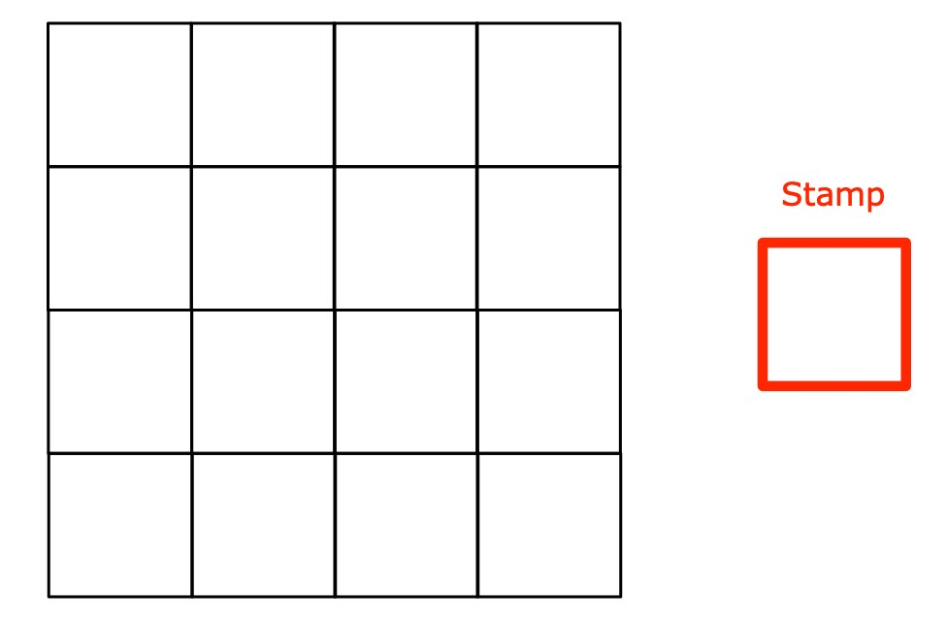

Depending on how she carries out the stamps, some of the **line segments** will be colored red. In the example below, she stamped 3 squares and there are 11 line segments that are colored red.



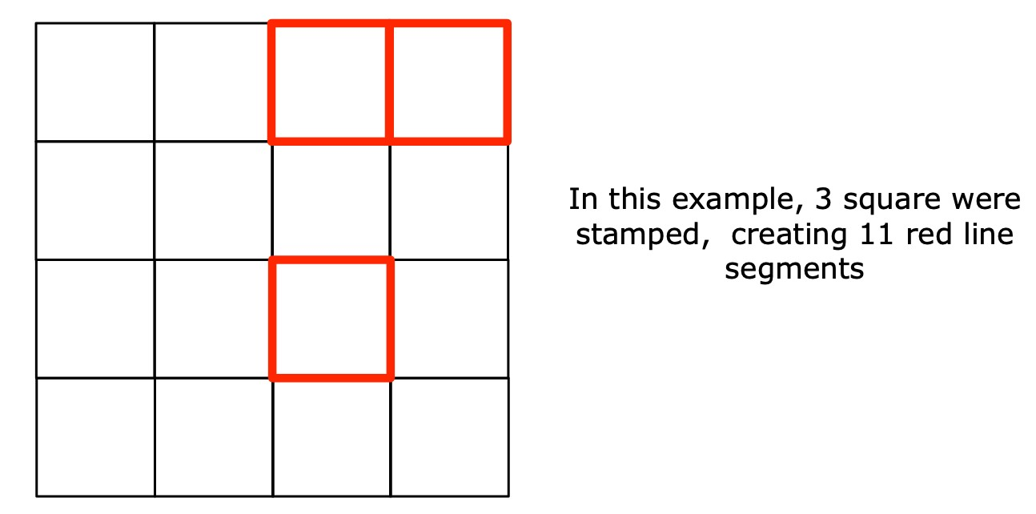

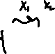

Based on the child’s game, answer the following:

* What is the probability that she stamps exactly 2 squares?

$$P\left(Die is even\right)=\left\{2, 4, 6\right\}=\frac{1}{2}=P\left(Stamp a square\right)$$

$$P\left(Square is not stamped\right)=\frac{1}{2} \left(Roll an odd\right)$$

Each square has a ½ chance of getting a stamp based on the dice roll.

Each square is independent, meaning the Binomial random variable formula can be used

$$P\left(2\right)=\left({16 \atop 2}\right){\left(\frac{1}{2}\right)}^{2}{\left(\frac{1}{2}\right)}^{14}=\frac{15}{8192}$$

* What is the expected number of squares that she stamps?

Each square is independent and follows linearity.

$$E\left(X\right)=np$$

$$E\left(X\right)=\frac{1}{2} chance*16 square=8 squares will get stamped$$

* What is the expected number of line segments that are colored red?

Total of 40-line segments in the 4 x 4 square.

Probability that a line segment gets marked red depends on the probability of the square getting stamped

Using linearity, focusing on the chance that one line segment gets stamped

$$P\left(R_{1}\right)=Probability that one line gets stamped=\frac{1}{2}$$

$$E\left(R\right)=E\left(R_{1}+R_{2}+…R_{40}\right)$$

$$E\left(R\right)=P\left(R_{1}\right)*n$$

$$E\left(R\right)=\frac{1}{2}*40=20 line segments will be stamped red$$

* Is the number of red line segments a Binomial random variable?

Binomial Random Variables are valid only if all Bernoulli trials are independent. If an adjacent square gest stamped, a line segment will become stamped regardless of what happens to the other square. Line segments at the outer border have a different probability compared to the line segments that share two squares. These are not independent, so the number of red lines is not a Binomial Random Variable.

**(b) 7 points** This year for your hiking vacation you are thinking of going to either Scotland or Finland. There is a 60% chance of you going to Scotland because flights are slightly cheaper there and only a 40% chance you go to Finland. If you have an injury while hiking, you will have to come home. In Scotland, the terrain is not so bad, so on any given day, the chance that you get injured is only 20%. In Finland it is 40%. The chance of injury from each day to the next is independent.

* What is the probability that you come home after the third day?

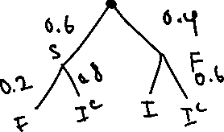

* Suppose you were injured on the first day, What is the probability that you were in Finland?

$$P\left(I_{1}\right)=0.2*0.6+0.4*0.4=0.28$$

$P\left(F | I_{1}\right)=\frac{P\left(F∩I_{1}\right)}{P(I_{1})}=\frac{\left(0.4*0.4\right)*0.4}{0.28}=\frac{8}{35} probability of being in Finland$

**(c) 6 points** Ten empty buckets are lined up in a row. Each bucket is labelled. A set of *n* balls are randomly thrown one after the other into the buckets.

* What is the expected number of throws that are necessary until two buckets have at least one ball in them? For example, if the first ball landed in bucket 1, and the second ball landed in bucket 2, then it only took me 2 throws. If the first ball landed in bucket 1 and the second ball landed in bucket 1, and the third ball landed in bucket 4, then it took me 3 throws.

$$n balls, 10 buckets$$

$$P\left(B_{2}\right)=Probability that a ball lands in a bucket twice$$

$$P\left(B_{2}^{'}\right)=Probability that a ball doesn^{'}t land in a bucket twice=1-P\left(B\right)$$

$$P\left(B_{2}|B_{1}\right)=\frac{\frac{1}{10}*\frac{1}{10}}{\frac{1}{10}}=\frac{1}{10}$$

First ball can start off in any bucket. The 2nd ball has 1/10 chance to match the same bucket.

$$P\left(B_{2}^{'}\right)=1- P\left(B_{2}\right)=\frac{9}{10}$$

$$E\left(2\right)=\frac{9}{10}*n expected throws$$

* After all *n* balls are thrown, what is the probability that the total number of balls in bucket 1 and bucket 2 is 4? (*Not 4 balls in each. A total of 4 balls in bucket 1 and bucket 2)*

$$The chance of a ball entering a bucket is independent from other balls: Bernoulli Random Variable$$

N trials of balls with only 4 specific successes out of n-4 trials

$$P\left(B_{1}\right)+P\left(B_{2}\right)=\frac{1}{10}+\frac{1}{10}=\frac{1}{5} to hit Bucket 1 or Bucket 2$$

$$\frac{8}{10} buckets or chances of failure$$

$$P\left(X\right)=\left({n \atop 4}\right){\left(\frac{1}{5}\right)}^{4}{\left(\frac{8}{10}\right)}^{n-4}$$